JAVA PROGRAM - (2/8/24/)

Anugraha N

(192371018)

Q1) write a java program to replace a 2nd element of array list to a specified element

import java.util.ArrayList;

import java.util.Scanner;

public class ReplaceElement {

public static void main(String[] args) {

ArrayList<String> list = new ArrayList<>();

list.add("A");

list.add("B");

list.add("C");

list.add("D");

System.out.println("Original List: " + list);

Scanner scanner = new Scanner(System.in);

System.out.print("Enter the new element to replace the second element:");

String newElement = scanner.nextLine();

if (list.size() > 1) {

list.set(1, newElement);

} else {

System.out.println("The list does not have a second element.");

}

System.out.println("Modified List: " + list);

scanner.close();

}

}

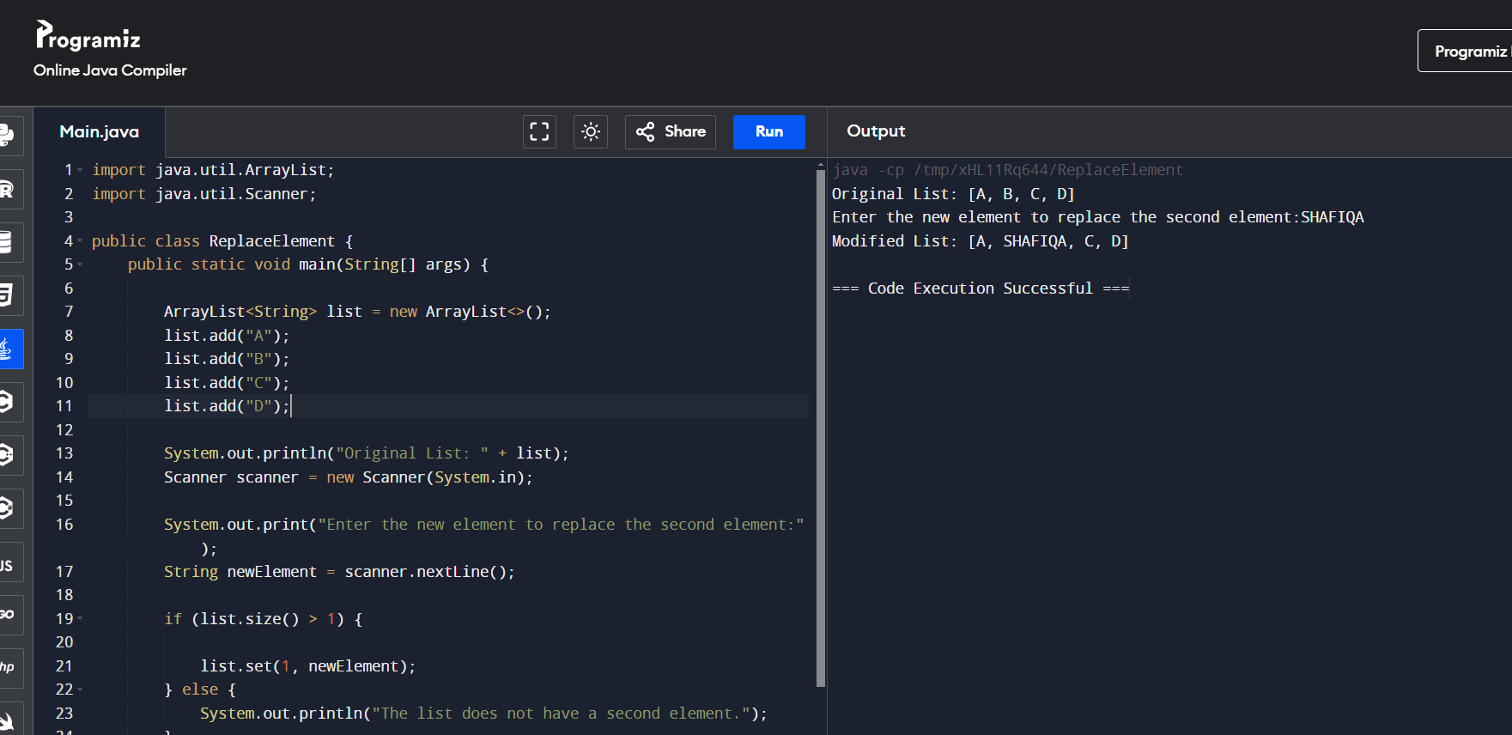

Q2) write a java prog to create a array list add some colors and print out the collections

import java.util.ArrayList;

public class ColorList {

public static void main(String[] args) {

ArrayList<String> colors = new ArrayList<String>();

colors.add("Red");

colors.add("Green");

colors.add("Blue");

colors.add("Yellow");

System.out.println(colors);

}

}

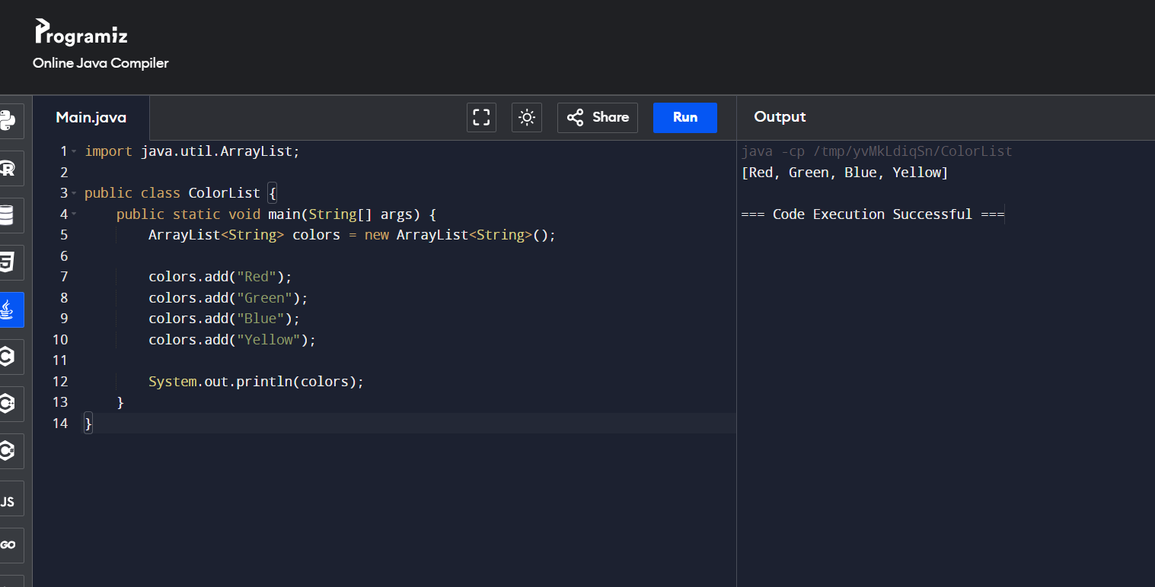

Q3) write a java program to reverse a program in the array list

import java.util.ArrayList;

import java.util.Collections;

public class ReverseArrayList {

public static void main(String[] args) {

ArrayList<Integer> numbers = new ArrayList<>();

numbers.add(1);

numbers.add(2);

numbers.add(3);

numbers.add(4);

numbers.add(5);

System.out.println("Original list: " + numbers);

// Method 1: Using Collections.reverse()

Collections.reverse(numbers);

System.out.println("Reversed list using Collections.reverse(): " + numbers);

// Method 2: Using a loop

ArrayList<Integer> reversedList = new ArrayList<>();

for (int i = numbers.size() - 1; i >= 0; i--) {

reversedList.add(numbers.get(i));

}

System.out.println("Reversed list using a loop: " + reversedList);

}

}

